Step 1 - Configuring our patch for Max4Live

Because the changes that needed to be made were minimal for this Max4Live implementation, we’ve provided a completed Max4Live instrument for this lab. The only caveat is that we’re working with samples and .sfz files which means instead of dragging the lone .amxd file into Ableton, we need to drag the entire 808 folder, complete with sound files, .sfz files as well.

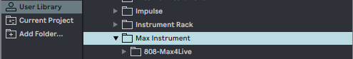

From this point, you need to drag the “LabX-Drums Final.amxd” onto a MIDI track like we have in the past. You’ll notice that the instrument already has a configured interface making use of “presentation view,” like we talked about in previous labs.

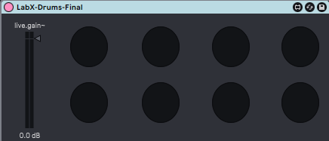

Step 2 - Sequencing MIDI Rhythms

For projects that we’ve done in Ableton for this class so far, we’ve had to sequence MIDI in order to send information to our Max4Live patch to playback to us. We’re going to take a look at a few of Ableton’s MIDI sequencing options beyond what we’ve already covered in previous labs. Remember to toggle the  icon to enable MIDI playback when you click the keys in the piano roll.

Just as a review, you might want to change the size of the grid for easy input, especially if you’re going to be inputting many notes of the same value (like in a drum beat, for instance). You can right click anywhere inside the piano roll and change the grid size in a variety of different ways. You can also change to a triplet subdivision of the grid in the right click menu as well.

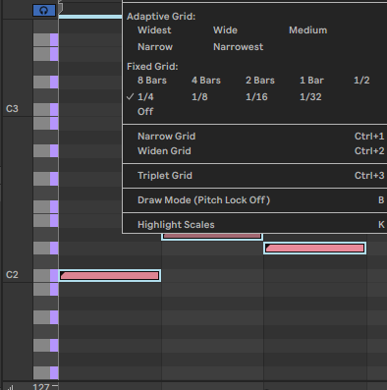

To change the velocity of a particular MIDI note, you can click and drag the horizontal sliders in the bottom region of the piano roll.

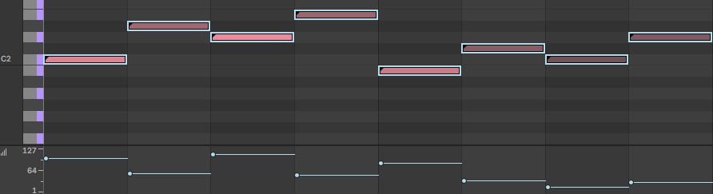

You can also make use of Ableton’s randomness settings by unselecting any MIDI notes, then clicking the  button.

With a number of MIDI notes selected, the parameter will attempt to gradually change from the first velocity value to the second.

You can add an element of human variation by making use of the  slider, which will add or remove a random amount of velocity to a given MIDI note each time it’s played back. To add deviation to a MIDI note, it must be selected below changing the deviation value.

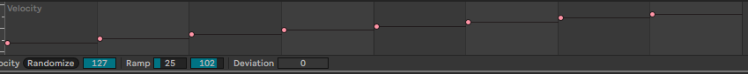

In the left panel of the piano roll, there are a few rhythm-centric options you can take advantage of.

With at least 1 note selected, you can use  to alter the length of any selected notes. You can achieve this by changing the grid and inputting notes, or by eye-balling the length of the note with the grid off, but this gives you computer accurate control while the grid remains the way you set it, which could be handy.

 adds another element of human variety. With at least 1 note selected, you can change the humanize value, then click the button to shift the notes slightly off of perfect quantization. To undo this, you can right click on the piano roll and click “Quantize”, or press ctrl/cmd + u.

Quantizing can also be changed to apply a bit of groove to your notes. To change quantization settings, right click on the piano roll, then click “Quantize Settings…”, or press ctrl/cmd + shift + u. In the menu to the left of the piano roll, you can experiment with the grid settings, and amount dial. It’s common for rhythms to have a slight swing. You can achieve this by toggling , and adjusting the amount dial to suit your taste.

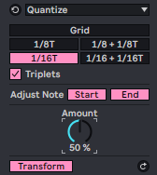

For this assignment, you’re going to submit a screenshot of one of the beat patterns below. Because we can’t label each key in the piano roll, you’ll have to keep in mind that our sampler starts at 36 and ends at 43. Each beat is 2 bars long, and the grid is set to 1/16. Notes that have a greyer color have a reduced velocity.

Beat 1 - “Raw D&B” 168-178 BPM

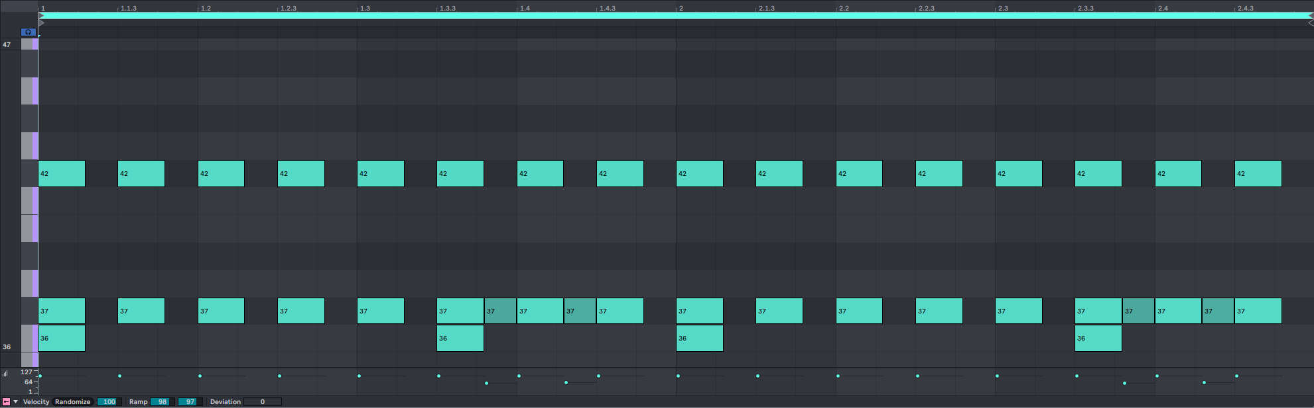

Beat 2 - “Motor City Techno” 120-125 BPM

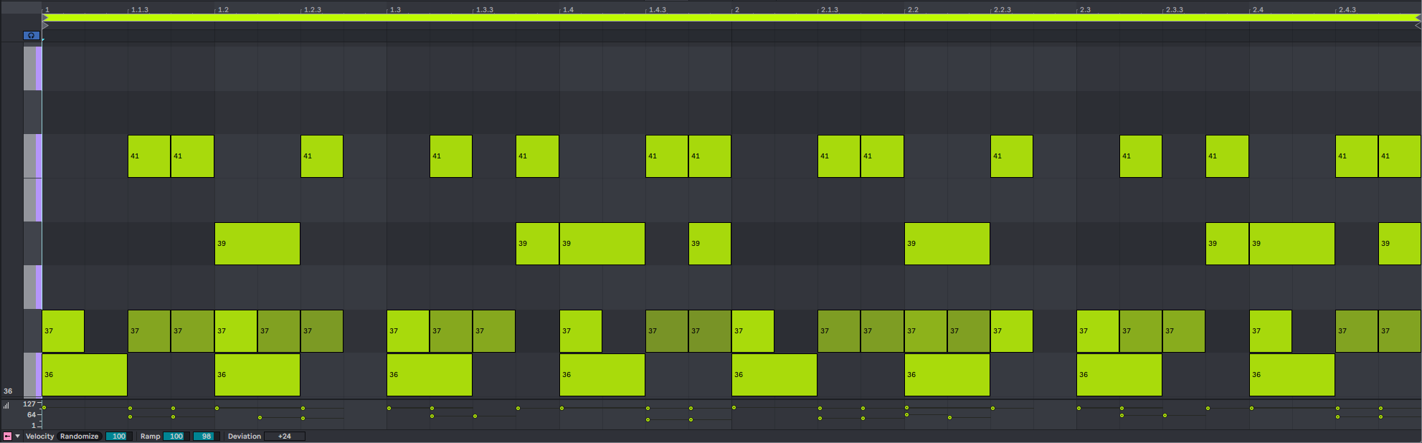

Beat 3 - “Sparse Chill” 75-85 BPM

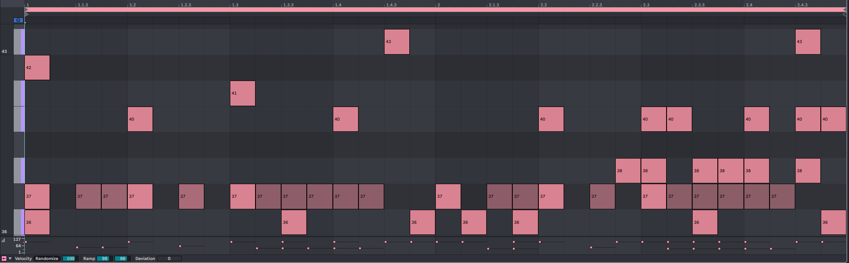

**Push goals -**

* Add one or more variations to one or more of the beat patterns.
* Describe how you varied the beat in comparison to the original.
* Compose a beat of your own.
* Experiment by changing which sample plays each part of your beat.